#5
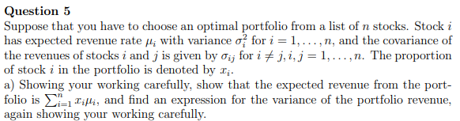
Part-a
Let $ρ_{p}=$rate of return of portfolio P
$Q_{p}\left(t\right)=$ value of portfolio at time t
$S_{i}\left(t\right)=$ value of asset $S_{i}$ at time t
$W_{i}=$value allocated to asset $S_{i}$ and $\sum_{i=1}^{n}{W_{i}}=W$
Using the fact that $Q_{p}\left(t\right)=\sum_{i=1}^{n}{\frac{W_{i}}{S_{i}\left(0\right)}}S_{i}\left(t\right)$
First, we will show $ρ_{P}\left(t\right)=\sum_{i=1}^{n}{w_{i}}ρ_{i}=\sum_{i=1}^{n}{x_{i}}ρ_{i}$
We have
$$ρ_{P}\left(t\right)=\frac{Q_{p}\left(t\right)-Q_{p}\left(0\right)}{Q_{p}\left(0\right)}$$
$=\frac{\sum_{i=1}^{n}{\frac{W_{i}}{S_{i}\left(0\right)}}S_{i}\left(t\right)-W}{W}$ because $Q_{p}\left(0\right)=W$
$=\left\{\sum_{i=1}^{n}{\frac{W_{i}}{W} \frac{S_{i}\left(t\right)}{S_{i}\left(0\right)}}\right\}-\left\{\sum_{i=1}^{n}{\frac{W_{i}}{W}}\right\}$
$=\sum_{i=1}^{n}{\left\{\left(\frac{W_{i}}{W}\right) \left[\frac{S_{i}\left(t\right)-S_{i}\left(0\right)}{S_{i}\left(0\right)}\right]\right\}}$
$=\sum_{i=1}^{n}{x_{i} ρ_{i}}$

The expected return of the portfolio is
$$μ_{P}=E\left(\sum_{i=1}^{n}{x_{i} ρ_{i}}\right)$$
$=\sum_{i=1}^{n}{E\left({ x}_{i} ρ_{i}\right)}$ by Linearity Property of expectation
$=\sum_{i=1}^{n}{{ x}_{i} E\left(ρ_{i}\right)}$
$=\sum_{i=1}^{n}{{ x}_{i} μ_{i}}$
The variance is
${σ_{P}}^{2}=E\left[{\left(ρ_{P}-μ_{P}\right)}^{2}\right]$ by definition of variance of a random variable
$$=E\left[{\left(\sum_{i=1}^{n}{x_{i} ρ_{i}}-\sum_{i=1}^{n}{{ x}_{i} μ_{i}}\right)}^{2}\right]$$
$$=E\left[{\left(\sum_{i=1}^{n}{x_{i}\left( ρ_{i}-μ_{i}\right)}\right)}^{2}\right]$$
$$=E\left[\left(\sum_{i=1}^{n}{x_{i}\left( ρ_{i}-μ_{i}\right)}\right) \left(\sum_{i=1}^{n}{x_{i}\left( ρ_{i}-μ_{i}\right)}\right)\right]$$
$$=E\left(\sum_{i,j=1}^{n}{x_{i}x_{j}\left( ρ_{i}-μ_{i}\right)\left( ρ_{j}-μ_{j}\right)}\right)$$
$=\sum_{i,j=1}^{n}{x_{i}x_{j} E\left( ρ_{i}-μ_{i}\right)\left( ρ_{j}-μ_{j}\right)}$ by Linearity Property of expectation
$=\sum_{i,j=1}^{n}{x_{i}x_{j} σ_{ij}}$ by definition of covariance

Part-b
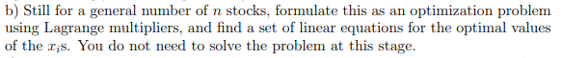
We want to minimize
$f\left(w_{1}, w_{2},...,w_{n}\right)=\frac{1}{2}\sum_{i,j=1}^{n}{w_{i}w_{j}}σ_{ij}$
subject to
$$g_{1}\left(w_{1}, w_{2,}...,w_{n}\right)=\sum_{i=1}^{n}{w_{i}}μ_{i}-μ_{p}=0$$
and
$$g_{2}\left(w_{1}, w_{2},w_{3}\right)=\sum_{i=1}^{n}{w_{i}}-1=0$$
The Lagrangian is
$$L\left(w_{1}, w_{2},..,w_{n}|λ_{1},λ_{2}\right)=f\left(w_{1}, w_{2},..,w_{n}\right)-λ_{1}g_{1}\left(w_{1}, w_{2},..,w_{n}\right)-λ_{2}g_{2}\left(w_{1}, w_{2},..,w_{n}\right)$$
The partial derivatives are
$\frac{∂L}{∂w_{i}}=w_{i}{σ_{i}}^{2}+\sum_{j≠i}{w_{j}σ_{ij}}-λ_{1}μ_{i}-λ_{2}$ for $i=1, 2, ...,n$
$$\frac{∂L}{∂λ_{1}}=-g_{1}\left(w_{1}, w_{2},{...,w}_{n}\right)=μ_{p} -\sum_{i=1}^{n}{w_{i}}μ_{i}$$
$\frac{∂L}{∂λ_{2}}=-g_{2}\left(w_{1}, w_{2},{...,w}_{n}\right)=\sum_{i=1}^{n}{w_{i}}-1$

To find the optimal portfolio given the desired expected return, (portfolio with the minimum variance), we solve the system of equations for $w_{i}’s$
$$\left\{\begin{matrix}\frac{∂L}{∂w_{i}}=0, for i=1, 2, ...,n \\ \frac{∂L}{∂λ_{1}}=0 \\ \frac{∂L}{∂λ_{2}}=0\end{matrix}\right.$$
Specifically, we solve for $w_{i}’s$ such that
$$\left\{\begin{matrix}w_{i}{σ_{i}}^{2}+\sum_{j≠i}{w_{j}σ_{ij}}-λ_{1}μ_{i}-λ_{2} =0 for i=1, 2, ...,n \\ μ_{p} -\sum_{i=1}^{n}{w_{i}}μ_{i}=0 \\ \sum_{i=1}^{n}{w_{i}}-1 =0\end{matrix}\right.$$

Part-c
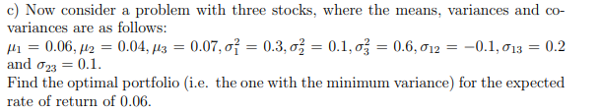
We want to minimize
$f\left(w_{1}, w_{2},w_{3}\right)=\frac{1}{2}\sum_{i,j=1}^{3}{w_{i}w_{j}}σ_{ij}$
$=\frac{1}{2}\left({w_{1}}^{2}{σ_{1}}^{2}+{w_{2}}^{2}{σ_{2}}^{2}+{w_{3}}^{2}{σ_{3}}^{2}+2w_{1}w_{2}σ_{12}+2w_{1}w_{3}σ_{13}+2w_{2}w_{3}σ_{23}\right)$
subject to
$$g_{1}\left(w_{1}, w_{2},w_{3}\right)=w_{1}μ_{1}+w_{2}μ_{2}+w_{3}μ_{3}-μ_{p}=0$$
and
$$g_{2}\left(w_{1}, w_{2},w_{3}\right)=w_{1}+w_{2}+w_{3}-1=0$$
The Lagrangian is
$$L\left(w_{1}, w_{2},w_{3}|λ_{1},λ_{2}\right)=f\left(w_{1}, w_{2},w_{3}\right)-λ_{1}g_{1}\left(w_{1}, w_{2},w_{3}\right)-λ_{2}g_{2}\left(w_{1}, w_{2},w_{3}\right)$$
$$=\left\{\begin{matrix}\frac{1}{2}{w_{1}}^{2}{σ_{1}}^{2}+\frac{1}{2}{w_{2}}^{2}{σ_{2}}^{2}+\frac{1}{2}{w_{3}}^{2}{σ_{3}}^{2}+w_{1}w_{2}σ_{12}+w_{1}w_{3}σ_{13}+w_{2}w_{3}σ_{23} \\ -λ_{1}\left(w_{1}μ_{1}+w_{2}μ_{2}+w_{3}μ_{3}-μ_{p}\right) \\ -λ_{2}\left(w_{1}+w_{2}+w_{3}-1\right)\end{matrix}\right.$$

$$\frac{∂L}{∂w_{1}}=w_{1}{σ_{1}}^{2}+w_{2}σ_{12}+w_{3}σ_{13}-λ_{1}μ_{1}-λ_{2}$$
$$\frac{∂L}{∂w_{2}}=w_{2}{σ_{2}}^{2}+w_{1}σ_{12}+w_{3}σ_{23}-λ_{1}μ_{2}-λ_{2}$$
$$\frac{∂L}{∂w_{3}}=w_{3}{σ_{3}}^{2}+w_{1}σ_{13}+w_{2}σ_{23}-λ_{1}μ_{3}-λ_{2}$$
$\frac{∂L}{∂λ_{1}}=-g_{1}\left(w_{1}, w_{2},w_{3}\right)=μ_{p}-w_{1}μ_{1}-w_{2}μ_{2}-w_{3}μ_{3}$
$\frac{∂L}{∂λ_{2}}=-g_{2}\left(w_{1}, w_{2},w_{3}\right)=1-w_{1}-w_{2}-w_{3}$
Next, we solve the system
$\frac{∂L}{∂w_{1}}=0$, $\frac{∂L}{∂w_{2}}=0$, $\frac{∂L}{∂w_{3}}=0$, $\frac{∂L}{∂λ_{1}}=0$, and $\frac{∂L}{∂λ_{2}}=0$
Substitute $μ_{1}=0.06$, $μ_{2}=0.04$, $μ_{3}=0.07$, $μ_{p}=0.06$
${σ_{1}}^{2}=0.3$, ${σ_{2}}^{2}=0.1$, ${σ_{3}}^{2}=0.6$
$σ_{12}=-0.1$, $σ_{13}=0.2$, $σ_{23}=0.1$
Specifically, we solve the system
$$\left\{\begin{matrix}{0.3w}_{1}-0.1w_{2}+0.2w_{3}-{0.06λ}_{1}-λ_{2}=0 \\ {0.1w}_{2}-0.1w_{1}+{0.1w}_{3}-0.04λ_{1}-λ_{2}=0 \\ \begin{matrix}{0.6w}_{3}+{0.2w}_{1}+{0.1w}_{2}-0.07λ_{1}-λ_{2}=0 \\ 0.06-{0.06w}_{1}-{0.04w}_{2}-{0.07w}_{3}=0 \\ 1-w_{1}-w_{2}-w_{3}=0\end{matrix}\end{matrix}\right.$$
We first eliminate $λ_{2}$ by subtracting [eqn 2] from [eqn 1] and subtracting [eqn 3] from [eqn 1]
$$\left\{\begin{matrix}{0.4w}_{1}-0.2w_{2}+0.1w_{3}-{0.02λ}_{1}=0 \\ {0.1w}_{1}-0.2w_{2}-0.4w_{3}+{0.01λ}_{1}=0\end{matrix}\right.$$
We eliminate $λ_{1}$ by adding twice the 2nd equation above to the first equation
$${0.6w}_{1}-0.6w_{2}-0.7w_{3}=0$$
Now, we solve
$$\left\{\begin{matrix}{0.6w}_{1}-0.6w_{2}-0.7w_{3}=0 \\ {0.06w}_{1}+{0.04w}_{2}+{0.07w}_{3}=0.06 \\ w_{1}+w_{2}+w_{3}=1\end{matrix}\right.$$
$1st+ \left(0.7×3rd\right)$ and $2nd+ \left(-0.07×3rd\right)$ gives
$$\left\{\begin{matrix}{1.3w}_{1}+0.1w_{2}=0.7 \\ {-0.01w}_{1}-{0.03w}_{2}=-0.01\end{matrix}\right.$$
$2nd+ \left(0.3×1st\right)$ gives
$0.38w_{1}=0.2$ so $w_{1}=\frac{20}{38}$ or $\frac{10}{19}$ or 0.526316
$$-0.01\left(\frac{10}{19} \right)-{0.03w}_{2}=-0.01$$
$w_{2}=\frac{0.01-0.01\left(\frac{10}{19} \right)}{0.03}=\frac{3}{19}$ or 0.157895
$w_{3}=1-\frac{10}{19}-\frac{3}{19}=\frac{6}{19}$ or 0.315789
We conclude that the optimal portfolio weights to achieve the expected rate of return of 0.06 with the minimum variance for the first, second, and third stocks are 10/19, 3/19, and 6/19, respectively.

Part-d
We repeat the same procedure above, but we replace $μ_{p}=0.06$ by $μ_{p}=0.065$
Specifically, we solve the system
$$\left\{\begin{matrix}{0.3w}_{1}-0.1w_{2}+0.2w_{3}-{0.06λ}_{1}-λ_{2}=0 \\ {0.1w}_{2}-0.1w_{1}+{0.1w}_{3}-0.04λ_{1}-λ_{2}=0 \\ \begin{matrix}{0.6w}_{3}+{0.2w}_{1}+{0.1w}_{2}-0.07λ_{1}-λ_{2}=0 \\ 0.065-{0.06w}_{1}-{0.04w}_{2}-{0.07w}_{3}=0 \\ 1-w_{1}-w_{2}-w_{3}=0\end{matrix}\end{matrix}\right.$$
$w_{1}≈$ 0.539474
$w_{2}≈$ -0.0131579 (close to zero)
$w_{3}≈$ 0.473684
This means that approximately, all amount invested in the second stock (less risky stock, ${σ_{2}}^{2}=0.1$) should be transferred to the third stock (more risky stock, ${σ_{3}}^{2}=0.6$).
In general, to increase the expected return, the level of risk must also be increased.

# 6
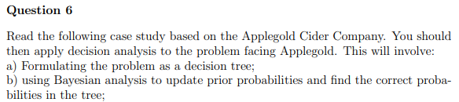
Part-a and Part-b

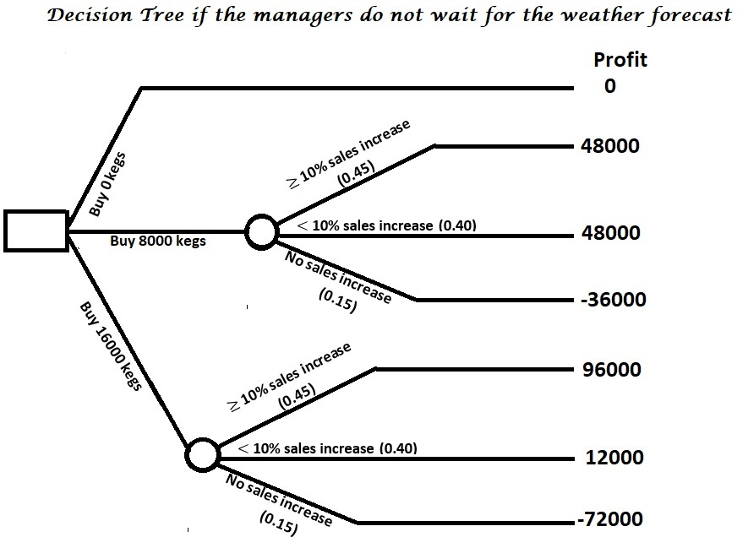
 |  | Alternatives
Events | Probability | Buy 0 kegs | Buy 8000 kegs | Buy 16000 kegs
≥ 10% sales increase | 0.45 | 0 | 48000 | 96000
< 10% sales increase | 0.40 | 0 | 48000 | 12000
No sales increase | 0.15 | 0 | -36000 | -72000
Expected Profit |  | 0 | 35400 | 37200

If the managers do not wait for the weather forecast, then the best strategy is to Buy 16000 kegs. It has the highest expected profit of 96000*0.45+ 12000*0.40-72000*0.15 = 37200.

Case # 1: Forecast is “$≥$ 10% sales increase”
P(Actual $≥$ 10% sales increase | Forecast is “$≥$ 10% sales increase”) = 17/31
P(Actual $<$ 10% sales increase | Forecast is “$≥$ 10% sales increase”) = 8/31
P(Actual NO sales increase | Forecast is “$≥$ 10% sales increase”) = 6/31

Forecast is "> 10% sales increase" |  |  | Strategies
Events |  | Probability | Buy 0 kegs | Buy 8000 kegs | Buy 16000 kegs
Kegs are available (0.7) | ≥ 10% sales increase | 17/31 | 0 | 84000 | 168000
Kegs are available (0.7) | < 10% sales increase | 8/31 | 0 | 84000 | 48000
Kegs are available (0.7) | No sales increase | 6/31 | 0 | -36000 | -72000
Kegs are NOT available (0.3) |  |  | 0 | 0 | 0
 | Expected Profit |  | 0 | 42,541.94 | 63,406.45

If the weather forecast indicates that the sales will increase by at least 10%, then the best strategy is to Buy 16000 kegs. It has the highest expected profit of
(168000*(17/31)+48000*(8/31)-72000*(6/31))*0.7+ 0*0.3 = 63,406.45

Case # 2: Forecast is “$<$ 10% sales increase”
P(Actual $≥$ 10% sales increase | Forecast is “$<$ 10% sales increase”) = 7/40=0.175
P(Actual $<$ 10% sales increase | Forecast is “$<$ 10% sales increase”) = 25/40 = 0.625
P(Actual NO sales increase | Forecast is “$<$ 10% sales increase”) = 8/40 = 0.20

Forecast is "< 10% sales increase" |  |  | Strategies
Events |  | Probability | Buy 0 kegs | Buy 8000 kegs | Buy 16000 kegs
Kegs are available (0.7) | ≥ 10% sales increase | 0.175 | 0 | 84000 | 168000
Kegs are available (0.7) | < 10% sales increase | 0.625 | 0 | 84000 | 48000
Kegs are available (0.7) | No sales increase | 0.20 | 0 | -36000 | -72000
Kegs are NOT available (0.3) |  |  | 0 | 0 | 0
 | Expected Profit |  | 0 | 42,000.00 | 31,500.00

If the weather forecast indicates that the sales will increase by less than10%, then the best strategy is to Buy 8000 kegs. It has the highest expected profit of
(84000*0.175 + 84000*0.625 - 36000*0.2)*0.7 + 0*0.3 = 42,000

Case # 3: Forecast is “No sales increase”
P(Actual $≥$ 10% sales increase | Forecast is “No sales increase”) = 2/25=0.08
P(Actual $<$ 10% sales increase | Forecast is“No sales increase”) = 7/25 = 0.28
P(Actual NO sales increase | Forecast is“No sales increase”) = 16/25 = 0.64

Forecast is "NO sales increase" |  |  | Strategies
Events |  | Probability | Buy 0 kegs | Buy 8000 kegs | Buy 16000 kegs
Kegs are available (0.7) | ≥ 10% sales increase | 0.08 | 0 | 84000 | 168000
Kegs are available (0.7) | < 10% sales increase | 0.28 | 0 | 84000 | 48000
Kegs are available (0.7) | No sales increase | 0.64 | 0 | -36000 | -72000
Kegs are NOT available (0.3) |  |  | 0 | 0 | 0
 | Expected Profit |  | 0 | 5,040 | -13,440

If the weather forecast indicates that the sales will not increase, then the best strategy is to Buy 8000 kegs. It has the highest expected profit of
(84000*0.08 + 84000*0.28 -36000*0.64)*0.7 + 0*0.3= 5,040

The overall expected profit if managers waited for the weather forecast is
(31/96)*63406.45 + (40/96)*42000 + (25/96)*5040 = 39,287.50

Since 39,287.50 > 37200 (Expected profit if weather forecast is not used), then the managers should wait for the weather forecast.
The optimal strategy would be:
- If the cost of obtaining the weather forecast is less than 39,287.50-37,200 = 2,087.50, then wait for the weather forecast
- If the weather forecast indicates that “sales will increase by more than 10%”, then Buy 16000 kegs
- If the weather forecast indicates that “sales will increase by less than 10%”, then Buy 8000 kegs
- If the weather forecast indicates that “sales will not increase, then Buy 8000 kegs
- If the cost of obtaining the weather forecast exceeds 39,287.50-37,200 = 2,087.50, then do not wait for the weather forecast and the best strategy is to Buy 16000 kegs immediately.

The Decision tree if the managers decided to wait for the weather forecast is given below.
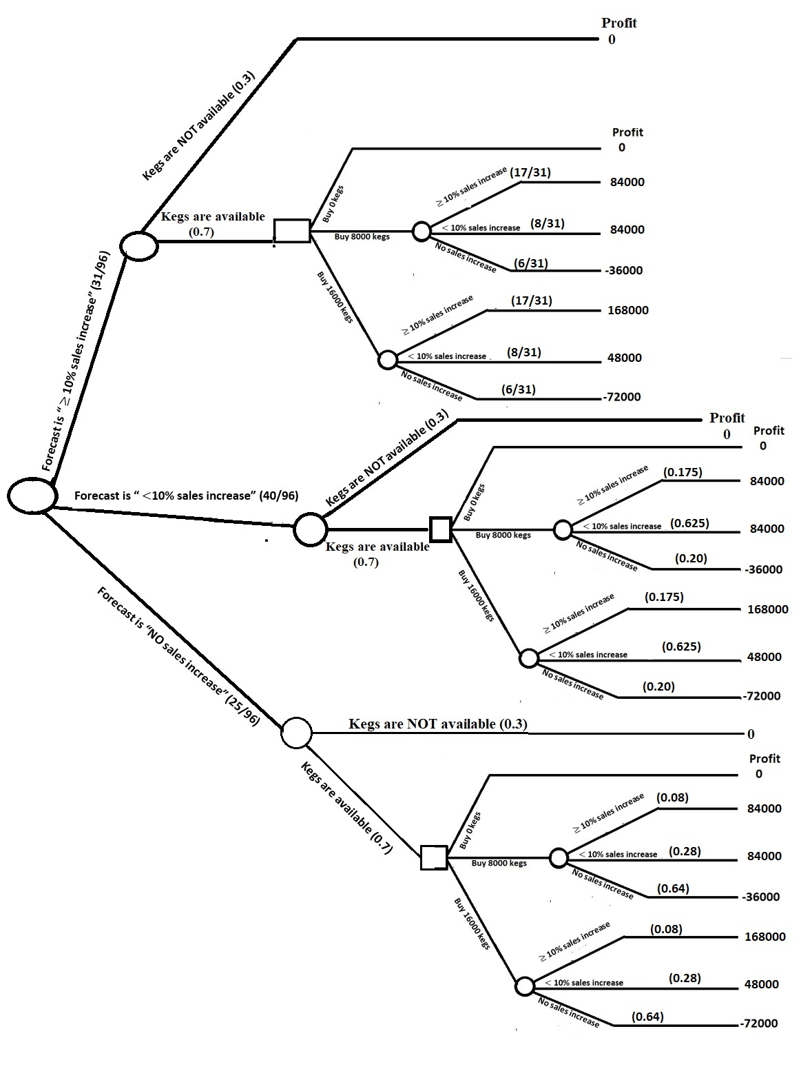

Part-c
The risk involved in making the decision is not considered. Although, we obtain the highest expected profit for each possible outcome, there is a possibility of making a negative profit. If we are willing to have a negative profit in exchange for a higher “expected” return, then the analysis would be useful.

